Survey measures used in analysis

Demographic and health-related characteristics
J1. Please record your gender
- Male
- Female
- Other
J2. Please record your age. You can choose to indicate your specific age, or indicate within an age range
Specific age
- Specify age
Age range
1. 18-29 years
2. 30-44 years
3. 45-59 years
4. 60 years and over
J4. What is your marital status?
1. Married
2. Defacto
3. Separated/Divorced
4. Widowed
5. Never married
J5. Which of these groups best describes the highest qualification you have obtained?
1. Still at school
2. Left school at 15 years or less
3. Left school after age 15
4. Left school after age 15 but still studying
5. Trade qualification/apprenticeship
6. Certificate/Diploma
7. Bachelor degree or higher
J6. Which of these best describes your work status?
1. Work full time
2. Work full time - self employed
3. Work part time
4. Work part time - self employed
5. Home Duties
6. Unemployed
7. Retired
8. Student
9. Other
10. Not working because of work related injury
11. Not working because of disability
J7. We are interested in how health relates to income. Before tax is taken out, which of the following ranges best describes your household's income, from all sources, over the last 12 months?
1. Up to 40,000
2. $40,001 - $80,000
3. $80,001 - $120,000
4. $120,001 - $160,000
5. $160,001 and over
B1. Which category best describes your household?
- Person living alone [Skip to next section]
Couple
- Couple living without others [Skip to next section]
- Couple living with child(ren) under 18
- Couple living with children under 18 and over 18
- Couple living with children over 18
- Couple who are responsible for children under 18 part time (but who may not live with you full time)
Single parent
- Single parent living with child(ren) under 18
- Single parent living with child(ren) under 18 and over 18
- Single parent living with children over 18
- Single parent who is responsible for children under 18 part-time (but who may not live with you full-time)
Other
- Non-related adults sharing house/apartment/flat without children present [Skip to next section]
- Other household type (Please specify)_____________________ [Skip to next section]

B2. For how many of these children are you a parent/guardian?
- Specify number _____________________________________________
B3. Please indicate the age ranges of the children that live with you:
- 0 – 2 years old
- 3 – 5 years old
- 6 – 8 years old
- 9 – 12 years old
- 13 – 14 years old
- 15 – 17 years old
- 18 years and over
J8. What is your postcode?
- Specify
J9. What is your approximate height without shoes?
- In centimetres
- In feet and inches
- Don’t know/can’t say
Displayed if J9 = 1
J9.1 Height in centimetres (drop down list, 100cm – 300 cm )
Displayed if J9 = 2
J9.2 Height in feet and inches (2 drop down lists, 3 – 9 feet, and 0 – 12 inches)

J10. What is your approximate weight (undressed in the morning)?
- Weight in kilograms
- Weight in stones and pounds
- Weight in pounds only
- Don’t know / can’t say
Displayed if J10 = 1
J10.1 Weight in kilograms (drop down list, 30kg to 300kg)
Displayed if J10 = 2
J10.2 Weight in stones and pounds (2 drop down lists, 3st – 40st, 0lbs – 14lbs)
Displayed if J10 = 3
J10.3 Weight in pounds only (drop down list, 40lbs to 560lbs)
J11. Do you consider yourself to be…?
- An acceptable weight
- Underweight
- Overweight
- Don’t know/Can’t say

Alcohol consumption characteristics
A2. On a day that you have an alcoholic drink, how many standard drinks do you usually have? (show picture)
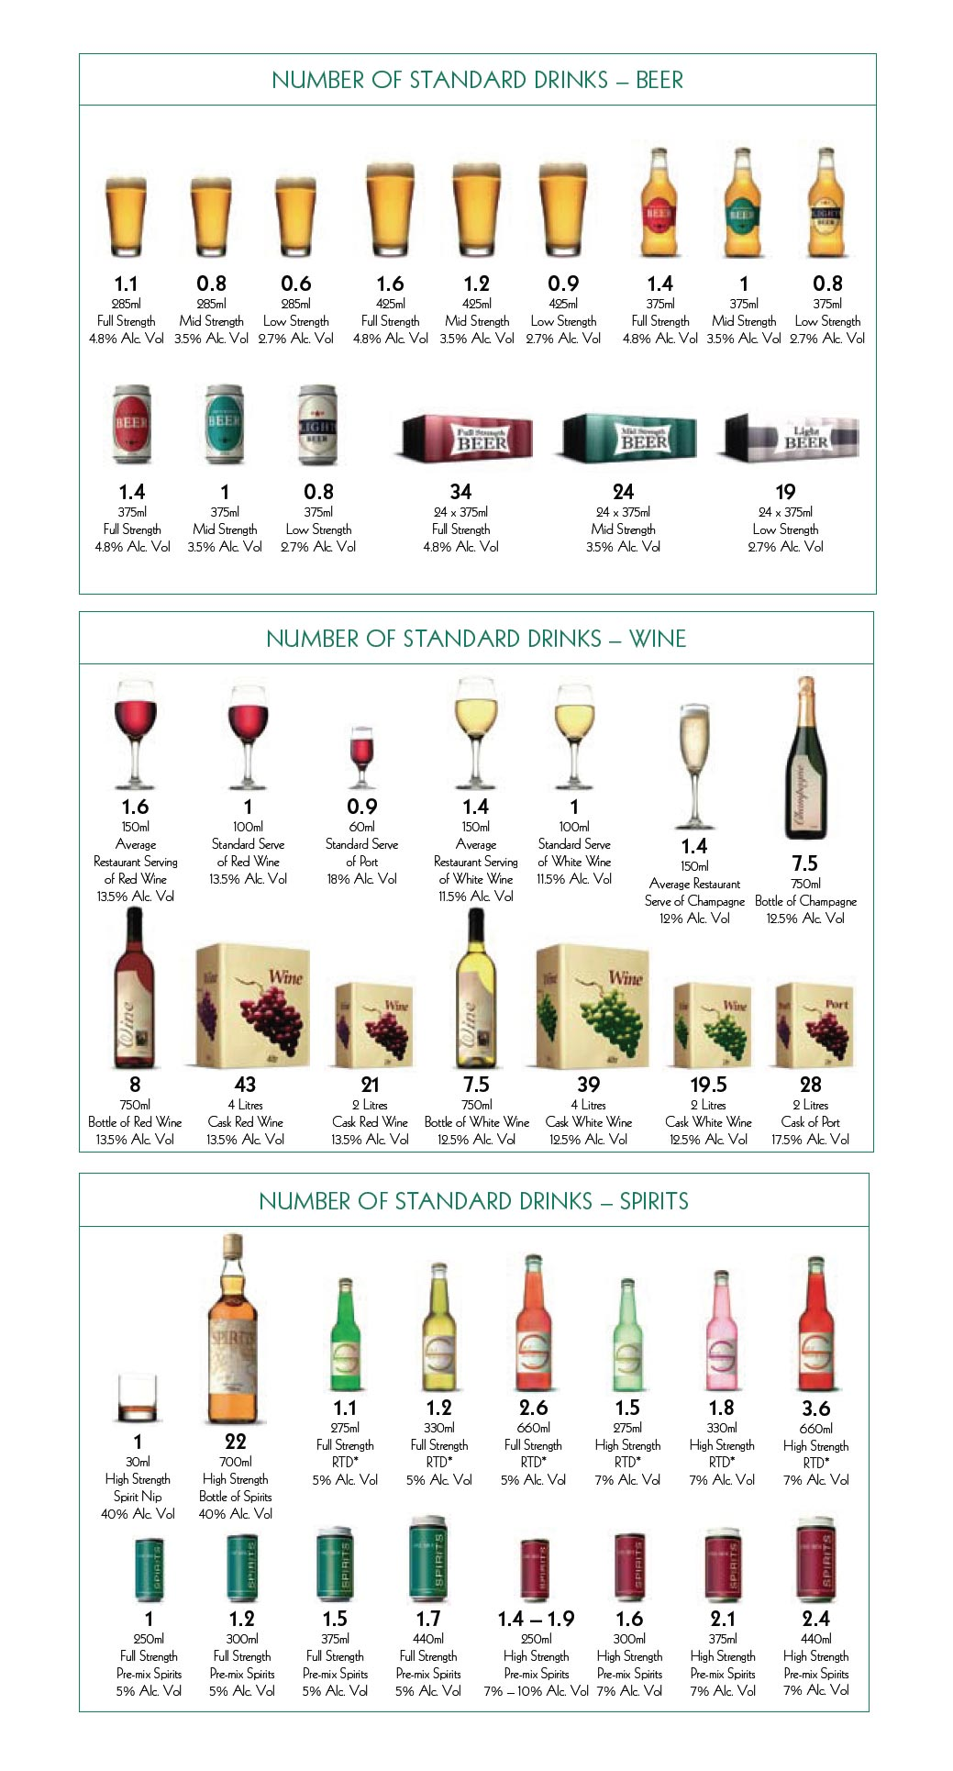
- 20 or more standard drinks
- 16-19 standard drinks
- 13-15 standard drinks
- 11-12 standard drinks
- 9-10 standard drinks
- 7-8 standard drinks
- 5-6 standard drinks
- 3-4 standard drinks
- 2 standard drinks
- 1 standard drink
- half a drink

A3. How often in the last 12 months have you had each of the following number of standard drinks in a day?
 | Everyday | 5 to 6 days a week | 3 to 4 days a week | 1 to 2 days a week | 2 to 3 days a month | About one day a month | Less often | Never
A3.1 ...20 or more standard drinks a day
A3.2 …11-19 standard drinks a day?
A3.3. …7-10 standard drinks a day?
A3.4. … 5-6 standard drinks a day?
A3.5. … 3-4 standard drinks a day?
A3.6. … 1-2 standard drinks a day?
A3.7. … less than 1 standard drink on average per day?
A3.8. … no alcohol in a day?

A1. In the last 12 months, how often did you have an alcoholic drink of any kind?
1. Every day
2. 5 to 6 days a week
3. 3 to 4 days a week
4. 1 to 2 days a week
5. 2 to 3 days a month
6. About 1 day a month
7. Less often [Go to next section]
8. Not in last 12 months [Go to next section]
9. No longer drink [Go to next section]
10. Never drunk alcohol [Go to next section]

I1. How many “standard drinks” do you believe an adult male could drink every day for many years without adversely affecting his health?
- Specify number
- Don’t know
I2. How many “standard drinks” do you believe an adult female could drink every day for many years without adversely affecting her health?
- Specify number
- Don’t know

Harm minimisation strategies used when consuming alcohol
A13. When you have an alcoholic drink, how often do you do any of the following?
 | Always | Most of the time | Sometimes | Rarely | Never
A13.1 Count the number of drinks you have
A13.2 Deliberately alternate between alcoholic and non-alcoholic drinks
A13.3 Limit the number of drinks you have in an evening due to driving
A13.4 Limit the number of drinks in an evening for other reason (e.g., to get up early for children, sport etc.)

Reductions in alcohol consumption
A11. In the last 12 months have you? (tick all that apply)
- Reduced the amount of alcohol you drink at any one time
- Reduced the number of times you drink during the day, week or month
- Switched to drinking drinks with lower alcohol content than you used to
- Stopped drinking alcohol for a period of time
- Stopped drinking alcohol completely
- None of the above [Go to next section]
- Don’t know/ unsure [Go to next section]
- Prefer not to answer [Go to next section]

Primary outcome: Changing alcohol consumption behaviours because of energy-related concerns
A13. When you have an alcoholic drink, how often do you do any of the following?
 | Always | Most of the time | Sometimes | Rarely | Never
A13.5 Drink lower carb alcohol because you are concerned about the calories/kilojoules
A13.6 Limit the number of drinks because you are concerned about the calories/kilojoules/effects on body weight

